EQs and Stats available in party stats.xlsx

**THE VERY GOOD FIGHT SYSTEM™**

**Tee em**

Battles should be **fast**, **fluid** and **frantic**. It’s a *s*ort of quick-paced, snappy battle system that feels like an extension of the overworld, rather than an interruption of it.

No lengthy animations or elaborate attack descriptions.

An ATB-ish system (active time battle) will be used to determine turn order. (CHECK OUT FINAL FANTASY 4)

Based on a character’s speed, their bar will fill up over time. Once full, the character is able to take a turn.

(MAYBE?) Certain enemy attacks take some off the bar, while your own critical hits add to it. Defeating an enemy also gives this bar a boost.

Once the bar fills up, it will add one to your Turn count (the # below the character’s sprite) and reset, starting to fill up again. This allows Turns to be stockpiled, allowing a character to take several turns in a row. For example, a healer might save up several turns and then heal the team multiple times in a row in a critical situation.

Some Spells cost more than one Turns to use, particularly Ash and Emi’s. You can use these even if you can’t afford them, though. This will put your turn count into the negatives, and you’ll need to wait for it to become positive before you can attack again.

Menus snappy and quick to navigate

3x3 grid for menu options

[Each spell type is essentially a folder, selecting one lets you choose the level of the spell. The cursor automatically jumps to the strongest level you can use at the moment]

Spell Critical Hits adding on bonus effects/buffs/debuffs

Pressing left and right allows you to cycle through characters with full bars

RANDOM NOTES:

Orbs, once obtained, can be used in battle, acting like a spell. One orb power can be used every time the orb meter at the top of the screen recharges. Any character can access these powers from the Misc. menu.

It takes quite a bit of time to fill up, but its charge level does not reset between battles

Completing the Blade of Prophecy cuts the number of recharge turns needed in half, or something? (THIS IS OLD?)

AMETHYST: Ups all character’s Speed for a few turns

PERIDOT: Heals all characters and removes any status conditions

SAPPHIRE: Surrounds all characters in a powerful shield (???)

RUBY: Attacks all foes with a tremendous blast

Players can take a Turn to recharge the bar by a bit

Enemies will occasionally drop perks in battle after they are defeated, such as +HP, +TURN, or +$$$, which then apply to the player that defeated that enemy.

Enemies drop money and items. Money can be traded for levels at the Save Station, as well as be used to buy weapons, armor, and other items.

HOW A FIGHT WORKS

BATTLE BEGINS

HUD elements fade in

Textbox displays the enemy’s entry flavor text (IE. BuffBoy’s sculpted bod blocks the path!)

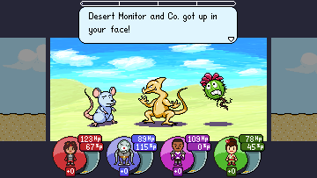

Action Bars start filling

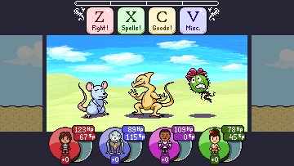

A character may take an action whenever the bar fills itself (turns may be stockpiled)

When only one character is able to attack, jump to them (selected char denoted by raised icon)

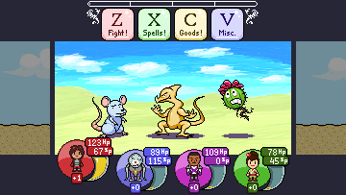

Select an action for that character

It is performed

On enemy defeat, show defeat flavor text (IE. Buffboy shrugs and walks off.)

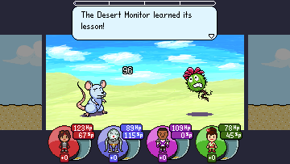

Repeat until all characters are defeated on either side

IF ALL ENEMIES DEFEATED

Show victory text/graphic/idk (YOU WON!!!!!! XD LOLOLOL)

Show money and item pickups if any

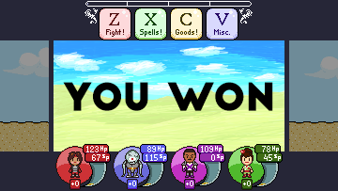

IF ALL PLAYERS DEFEATED

Game over yo

BATTLE ENDS

ACTION BAR

All characters’ Action Bars pause when examining a menu

ACTIONS

Fight!

Press Z to Fight!

Choose a target and then attack w/ your weapon, damage based on ATK stat

Gruss’s tentacles deal damage to all enemies at once (too bad his ATK sucks)

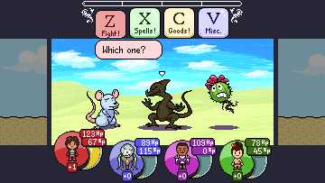

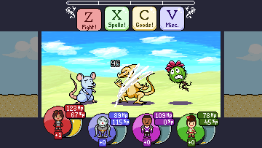

Spells!

Press X to use a Spell!

Opens a menu of all known spells

Choose one, and then select a target, if necessary. Animation plays.

Damage based on M. ATK and MIND stat I think lmao

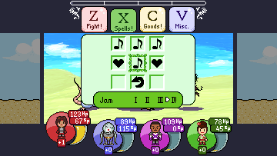

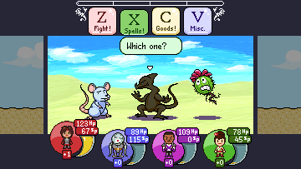

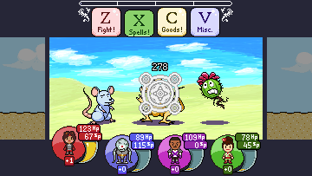

Goods!

Press C to use items!

Look at and use some items! Each character can carry nine different kinds of items

Choose a target for the item! Party for healing items or enemies for one-shot weapons

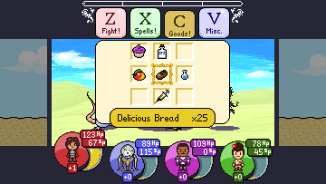

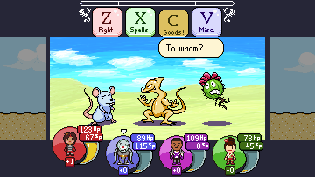

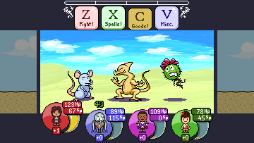

Misc.

Press V to perform miscellaneous actions

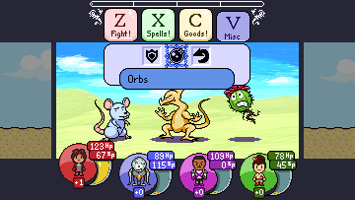

DEFEND

Halves all damage done to this character this turn

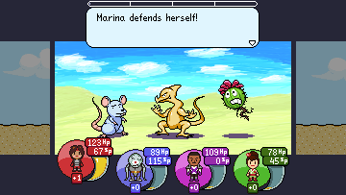

RUN AWAY

Attempt to escape the fight. 75% success rate. Enemies remain on overworld

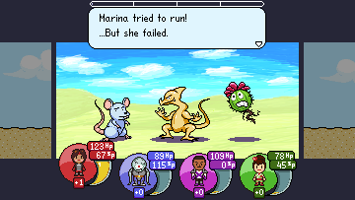

ORBS

Orbs get their own sub menu!

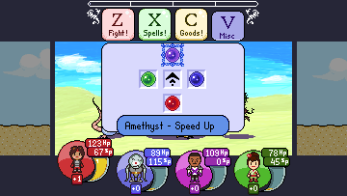

The orbs must be earned throughout the story. Each can perform a different spell. The top bar must be fully filled before you can use any of them. The middle option here allows the character to sacrifice a turn in order to greatly increase the bar

PLAYER CLASS ATTRIBUTES

NAME

The character’s name (Marina, Gruss, etc.)

STATS

Max HP, Current HP, Max SP, Current SP, Attack, Def, Magic Attack, Magic Def, Speed, Mind

SPELL LIST

All Spells currently known by the character

INVENTORY

All goods currently held by the character

GENDER

Send this to text writer to make things easier. (“BuffBoy flexed its arms” VS “Marina flexed her arms”)

ENEMY CLASS ATTRIBUTES

NAME

The enemy’s name (BuffBoy, Huge Awful Slime Thing, Carl, etc)

STATS

Max HP, Current HP, Max SP, Current SP, Attack, Def, Magic Attack, Magic Def, Speed, Mind

ELEMENTAL WEAKNESS/RESISTANCE

Damage modifiers to different spell types (Plant enemies weak to fire, etc)

ACTIONS

Actions enemy is capable of taking

GOLD

Money dropped after battle

ITEMS DROPPED

Any items dropped by the enemy on defeat (BuffBoy’s Speedo, etc)

-DROP RATE

% chance of dropping said item

ENTRY FLAVOR

Text displayed @ battle start (BUFFBOY DRAWS NEAR)

EXIT FLAVOR

Text displayed @ enemy’s defeat (BUFFBOY BURST INTO FLAMES)

SPRITE

The graphic representing the enemy in battle (buffboy.png)

GENDER

Send this to text writer to make things easier. (“BuffBoy flexed its arms” VS “Marina flexed her arms”)